German morale faltering

23rd February 1943: British intelligence assesses German attitudes to the war in the wake of Stalingrad
FEB 23

SAVE |  | ▷ LISTEN

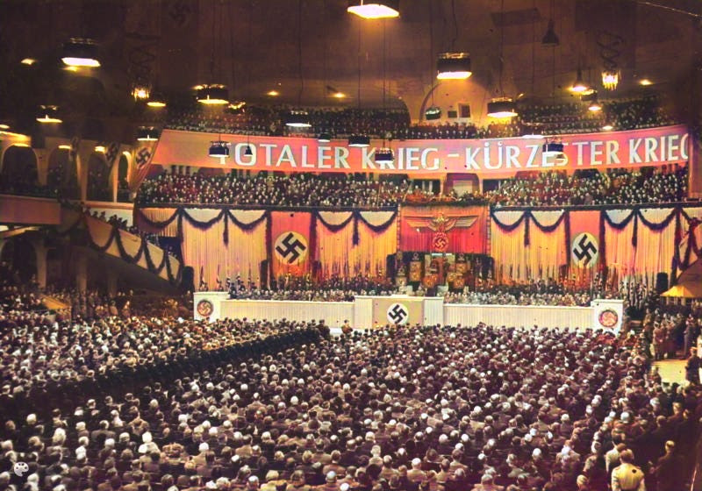
Colourised image of the Nazi gathering at the Sports Palast addressed by Goebbels.
Somewhere between the fanatical Nazis who attended the Sports Palast to hear Goebbels call for Total War and the tiny minority who were actively prepared to speak out lay the majority of ordinary Germans. It was to be expected that they were growing uneasy about the war and where it was headed. It was more difficult to determine how they might react. Of particular interest were the attitudes of those in the military command, who might yet be in a position to alter the course of the war.
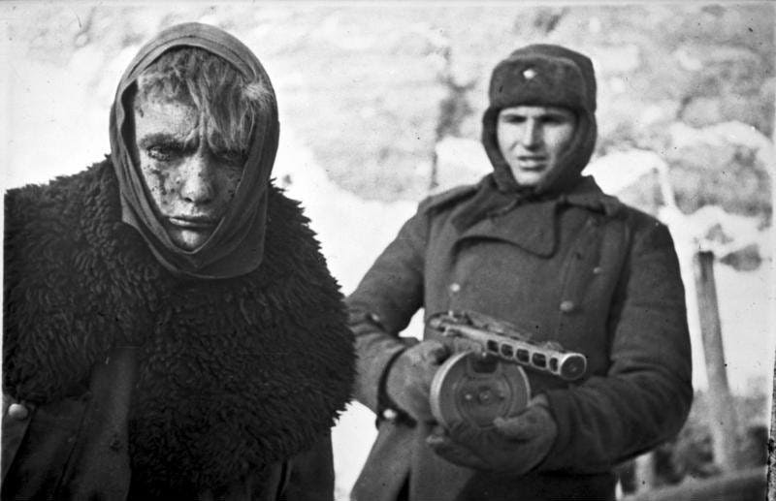
The reasons for the disaster at Stalingrad could not be openly discussed within Germany but many rumours were circulating.
British Intelligence was doing everything it could to monitor the state of German morale, picking up whatever it could from neutral foreign nationals who visited Germany, from interrogating prisoners of war and from critically examining Nazi propaganda messages. This was just one of many regular reports being made to the British War Cabinet¹:
23 February 1943
The speeches of German leaders on the tenth anniversary of Hitlers rise to power on the 30th January indicated that important differences of opinion exist between the Army leaders, among whom criticism of Hitler's military leadership is now widespread, and the party, particularly with regard to the original necessity and present conduct of the Russian war.
They also implied a difference of opinion between those prominent people who had hoped to patch up a peace with Russia and those who wished to obtain a compromise peace with the Western Powers.
German propaganda has found it necessary to combat the idea that an arrangement with Soviet Russia is possible. Even more striking is the fact that for the first time it is a major preoccupation of German propaganda to prove that the Western Powers either cannot or do not desire to save Germany and Europe from Bolshevisation.
Considerable sections of the propertied classes, especially bankers, heavy industrialists and Junkers, appear already to regard defeat as probable, and are obviously anxious to reinsure with the Western Powers.
Such defeatist tendencies are not yet widespread, although there is now a general realisation that Germany can no longer expect to win a complete victory. The tone of German propaganda suggests that the authorities fear that defeatism may gain ground, and in order to counteract it they ar e finding it necessary to hold out hopes of an improvement in the military situation by next summer. By such means they appear hitherto to have secured general acceptance of the sacrifices required for the successful prosecution of a long and bitter defensive war.
Large numbers of people have begun to compare 1943 with 1918, to ask whether the war has reached its turning point and to cast about for a third alternative open to the German people between Nazi victory and Russian vengeance.
...
Generally speaking, German morale is passing through a much more critical stage than in any previous winter of the war. German opinion no longer displays, either at the level of the masses or among the privileged classes, that uniformity which has hitherto characterised it, and which may be regarded as the hallmark of a successful totalitarian state.
Large numbers of people have begun to compare 1943 with 1918, to ask whether the war has reached its turning point and to cast about for a third alternative open to the German people between Nazi victory and Russian vengeance. This tendency is only incipient, and certainly does not betoken the imminence of any popular revolt.
But, unless the Russian advance can be checked on some new defensive line in Russia, public unrest is likely to grow.
German opinion is now more responsive than at any earlier stage of the war to the fortunes of battle at the fronts, to our air raids and to our political warfare. In these circumstances, there is an imminent danger of a crisis in the higher ranks of the army and administration.
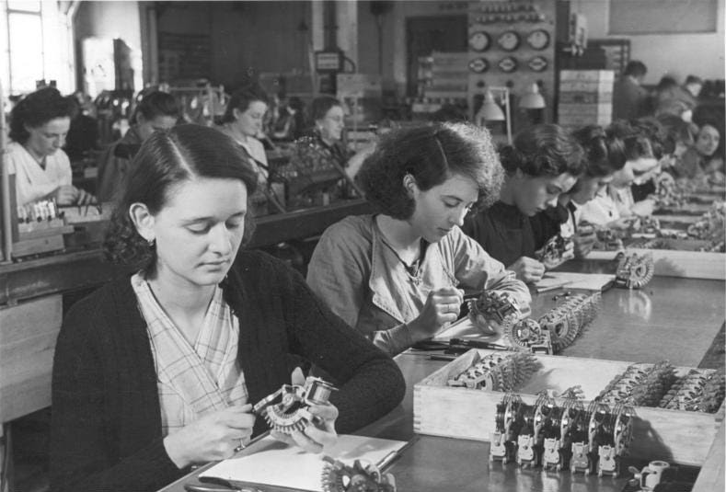
More and more German men were being conscripted and sent to the front, replaced by foreign workers such as these French women working for Siemens.
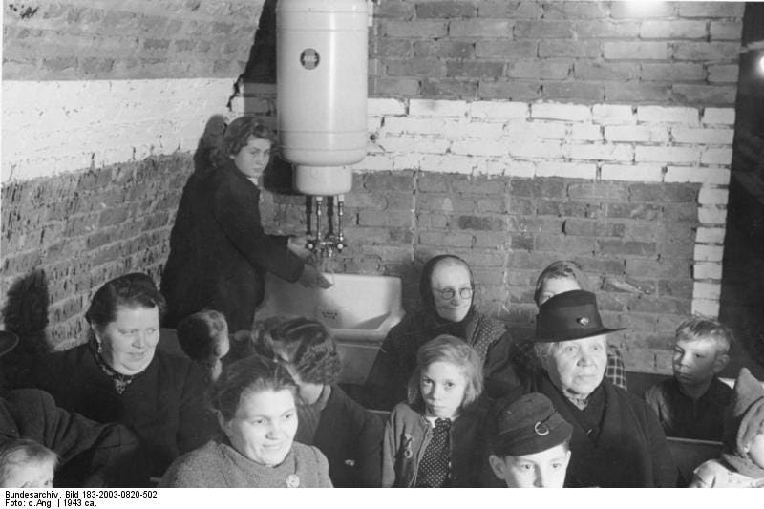
Bombing raids were already changing civilian life in Germany but would now grow in frequency and intensity.
1
From the British War Cabinet Minutes and Discussion Papers see TNA CAB 66/34/32

